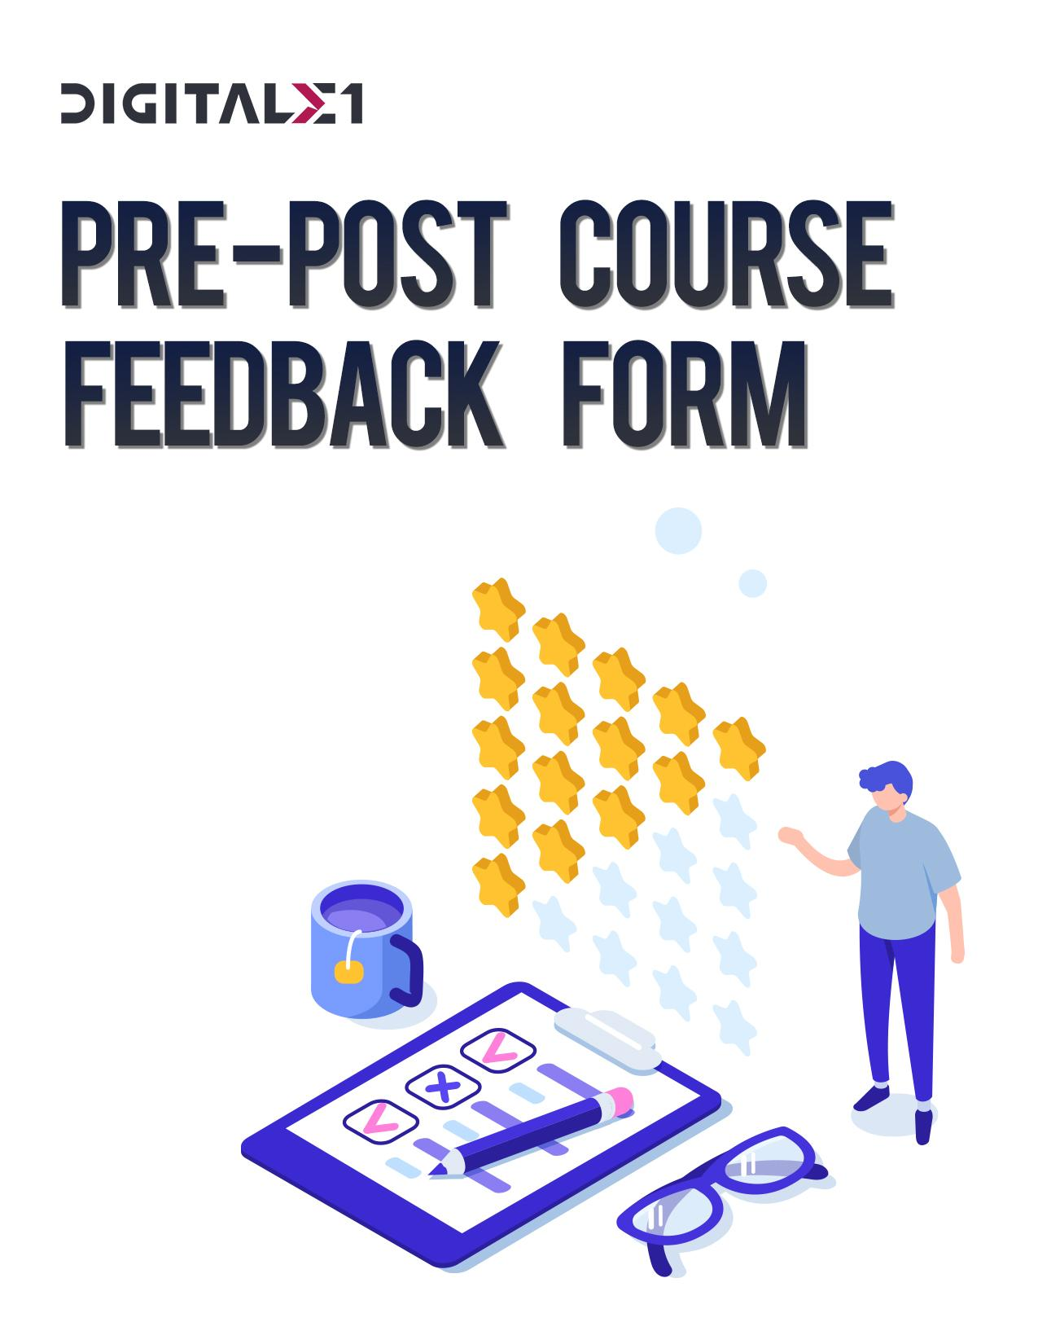

REACT.JS | **DAY 2**



**DAY 2**

|  |  |  |  |  |  |  |  |  |  |  |  |
| --- | --- | --- | --- | --- | --- | --- | --- | --- | --- | --- | --- |
| Rating Scale | **UNHEARD** | | **AWARE** | | **BASIC** | | | **SKILLFUL** | | **MASTERY** | |
| Topic: React.js introduction | **PRE** | **POST** | **PRE** | **POST** | | **PRE** | **POST** | **PRE** | **POST** | **PRE** | **POST** |
| Why we need React.js |  |  |  |  | |  |  |  |  |  |  |
| How React.js is best |  |  |  |  | |  |  |  |  |  |  |
| Bowser DOM vs. Virtual DOM |  |  |  |  | |  |  |  |  |  |  |
| Creating react basic example |  |  |  |  | |  |  |  |  |  |  |

0 - **Unheard** – Never heard about the topic.

1 - **Aware** – Some understanding but observable, demonstrated behavior is at a level below the expected for this competency.

2 - **Basic** - Some positive indicators are evident; an inconsistent demonstration.

3 - **Skillful** - A consistent performance with most of the behaviors being demonstrated.

4 - **Mastery** - A strong performance in this competency with all evidence relating to the positive indicators being frequently 1and consistently demonstrated.